Fuel loads at Ft Benning based on soil type and time since last burn

For sandy soils (fuel loads are in tons per acre)

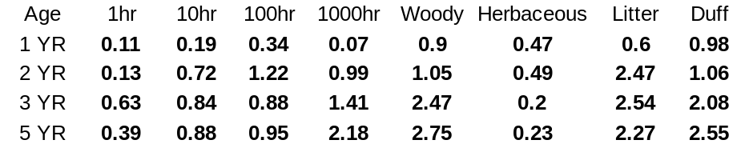

The above breakdown used by the photoseries to estimate the fuel loads does not match what is used by the Fire Emissions Production Simulator (FEPS). The correct breakdown for FEPS is

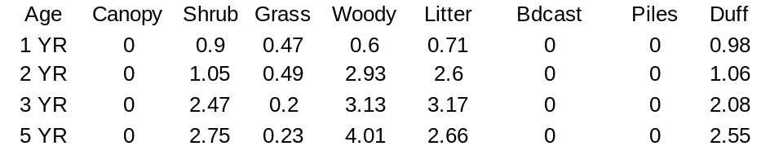

For clay soil sites we only had two year old rough sites to work with.

For use with FEPS:

